**Session 1 : How to solve big data**

**Assignment 2**

**Explain the below Linux commands with an example. Share the screenshot of each command with the output:**

**1. pwd 2. vi 3. touch 4. mkdir 5. rm 6. ls 7. echo 8. cat 9. who 10. cd 11. date 12. cal 13. mv 14. cp 15. which**

1. Pwd

‘pwd‘ stands for ‘Print Working Directory‘. As the name states, command ‘pwd‘ prints the current working directory or simply the directory user is, at present. It prints the current directory name with the complete path starting from root (/). This command is built in shell command and is available on most of the shell – bash, Bourne shell, ksh,zsh, etc.

For e.g.



1. Vi

To start vi

vi filename is used for Create or Edit filename starting at line 1

vi -r filename is used for Recover filename that was being edited when system crashed

To exit vi

:x Quit vi, writing out modified file to file named in original invocation

:wq Quit vi, writing out modified file to file named in original invocation

:q Quit or exit vi

:q! Quit vi even though latest changes have not been saved for this vi call

For e.g.

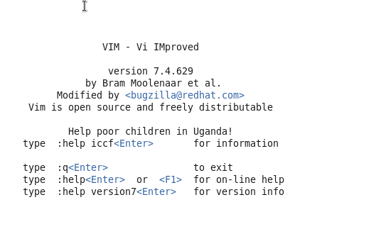

1. touch

The touch command updates the access and [modification](https://www.computerhope.com/jargon/m/modify.htm) times of each FILE to the current system time.

If you specify a FILE that does not already exist, touch creates an empty file with that name (unless the -c or -h options are specified; see below).

If the FILE argument is a dash ("-") is handled specially and causes touch to change the times of the file associated with standard output.

For e.g.

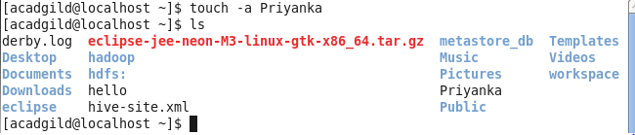

1. mkdir

Short for "make directory", mkdir is used to create [directories](https://www.computerhope.com/jargon/d/director.htm) on a [file system](https://www.computerhope.com/jargon/f/filesyst.htm). If the specified DIRECTORY does not already exist, mkdir creates it.

More than one DIRECTORY may be specified when calling mkdir.

For e.g.

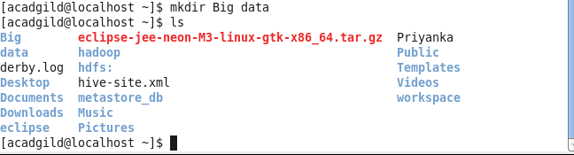

1. rm

rm removes each specified FILE. By default, it does not remove directories. The removal process [unlinks](https://www.computerhope.com/unix/unlink.htm) a file name in a [filesystem](https://www.computerhope.com/jargon/f/filename.htm) from [data](https://www.computerhope.com/jargon/d/data.htm) on the [storage device](https://www.computerhope.com/jargon/s/stordevi.htm), and marks that space as usable by future [writes](https://www.computerhope.com/jargon/w/write.htm).

For e.g.

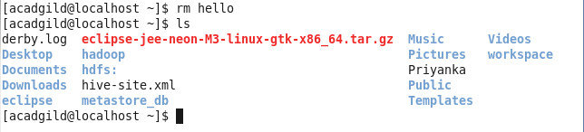

1. ls

List information about the FILEs (the current directory by default). Sort entries alphabetically if none of -cftuvSUX nor --sort is specified.

For e.g.



1. echo

echo is a fundamental command found in most [operating systems](https://www.computerhope.com/os.htm) that offer a [command line](https://www.computerhope.com/jargon/c/commandi.htm). It is frequently used in [scripts](https://www.computerhope.com/jargon/s/script.htm), [batch files](https://www.computerhope.com/jargon/b/batchfil.htm), and as part of individual commands; anywhere you may need to insert text.

Many command shells such as [bash](https://www.computerhope.com/unix/ubash.htm), [ksh](https://www.computerhope.com/unix/uksh.htm) and [csh](https://www.computerhope.com/unix/ucsh.htm) implement echo as a built-in command.

bash is the default command shell in nearly every major Linux [distribution](https://www.computerhope.com/jargon/v/variant.htm), so in this documentation we will look at the behavior, syntax, and options of bash's implementation of echo.

For e.g.



1. cat

cat stands for "catenate." It reads [data](https://www.computerhope.com/jargon/d/data.htm) from [files](https://www.computerhope.com/jargon/f/file.htm), and outputs their contents. It is the simplest way to display the contents of a file at the [command line](https://www.computerhope.com/jargon/c/commandi.htm).

For e.g.



1. Who

The who command prints information about all users who are currently logged in.

For e.g.

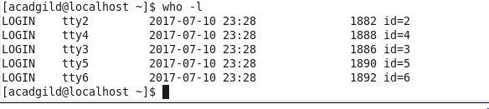

1. cd

The cd command, which stands for "change directory", changes the [shell](https://www.computerhope.com/jargon/s/shell.htm)'s [current working directory](https://www.computerhope.com/jargon/c/currentd.htm).

For e.g.

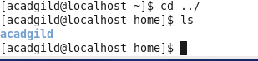

1. date

The date command is used to print out, or change the value of, the system's time and date information.

For e.g.



1. cal

Display a conveniently-formatted calendar from the command line.

For e.g.

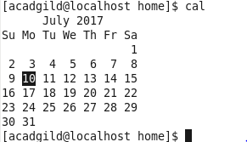

1. mv

The mv command is used to move or [rename](https://www.computerhope.com/jargon/r/rename.htm) files. mv renames file SOURCE to DEST, or moves the SOURCE file (or files) to DIRECTORY.

For e.g.

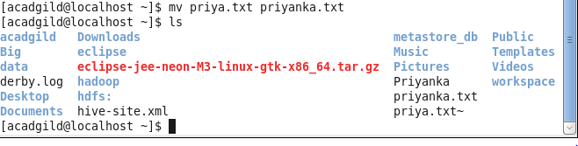

1. cp

The cp command is used to make copies of files and directories.

For e.g.

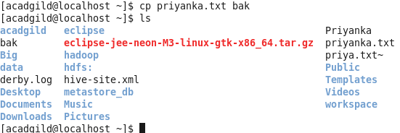

1. which

which returns the [pathnames](https://www.computerhope.com/jargon/p/path.htm) of the [files](https://www.computerhope.com/jargon/f/file.htm) (or [links](https://www.computerhope.com/unix/link.htm)) which would be [executed](https://www.computerhope.com/jargon/e/execute.htm) in the current [environment](https://www.computerhope.com/jargon/e/environm.htm), had the *filename* (or *filename*s) been given as a command (or commands) in a strictly [POSIX](https://www.computerhope.com/jargon/p/posix.htm)-conformant [shell](https://www.computerhope.com/jargon/s/shell.htm). It does this by searching the paths in the PATH [environment variable](https://www.computerhope.com/jargon/e/envivari.htm) for executable files matching the names of the arguments. which does not follow [symbolic links](https://www.computerhope.com/jargon/s/symblink.htm).

For e.g.

